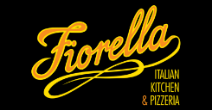

Fiorella

Thanks for your order, Jim!
We'll confirm your pickup time soon. Check your text messages for updates or click below to track the status of your order.
Track Order

Pickup Time:
Today, Oct 20, 2024 8:15 PM - 8:25 PM
Pickup Address:
152 National Plaza, Oxon Hill, MD 20745, USA

 | Get order updates on your phone.  Text "START" to (650) 852-1029 to get SMS updates on your orders. Powered by our partner DoorDash.

Your receipt
Order #5fa0811d
1x | Chicken Parmesan | $28.00
1x | Garlic Bread | $7.00

Subtotal | $35.00
Regulatory bag fee | $0.10
Taxes | $2.10

Total Charged  Visa***4571  Oct 20, 2024 | $37.20

We'd love to hear from you! Please take our quick survey to provide feedback on your experience.
Need assistance? Get order help or call (301) 839-1811.

